|  |  |  |  |
| --- | --- | --- | --- |
| **US Radiocommunication Sector**  **FACT SHEET** | | | |
| **Study Group:** USWP 7C | | | **Document No:** US7C-27-33NC |
| **Reference:** Annex 13 to Document 7C/142 | | | **Date:** 12 February 2024 |
| **Document Title:** Updates to the working document on sharing and compatibility studies regarding WRC-27 AI 1.19. | | | |
| **Authors**  Alfredo Mistichelli  NOAA  Tomasz Wojtaszek  NOAA  Edna Prado  NOAA  Botan Karim  NOAA  Christopher Hough  NOAA  Dan Bishop  NASA  Jason Szklany  NASA  Giovanni DeAmici  NASA | **Telephone**  240 624-0973  301 456-4574  301 628 5742  248 227-8895  301 323-8212 | **E-Mail**  alfredo.mistichelli@noaa.gov  tomasz.wojtaszek@noaa.gov  edna.prado@noaa.gov  botan.karim@noaa.gov  christopher.hough@noaa.gov  [Daniel.w.bishop@nasa.gov](mailto:Daniel.w.bishop@nasa.gov)  [jszklany@asrcfederal.com](mailto:jszklany@asrcfederal.com)  [Giovanni.deamici@nasa.gov](mailto:Giovanni.deamici@nasa.gov) | |
| **Purpose:** To provide updates to Document 7C/142 Annex 13. These updates include the analysis assumptions used to model the technical and operational characteristics and deployment strategies of the incumbent services, propagation modeling assumptions, and the modeling of the technical and operational characteristics and deployments of EESS (passive) systems. | | | |
| **Abstract:** Resolution 674 (WRC-23) notes that complementary bands need to be determined to ensure the continuity of SST measurements by EESS (passive). WRC-27 AI 1.19 considers sharing and compatibility studies to determine the possibility of a new primary allocation in all regions to the EESS (passive) in the 4 200 – 4 400 MHz and 8 400 – 8500 MHz frequency bands, without protection from existing services in these frequency bands and in adjacent bands. This contribution updates the working document for sharing and compatibility studies in the Chair’s Report of the September 2024 WP 7C meeting. | | | |
| **Fact Sheet Preparer:** Botan Karim, NOAA | | | |

|  |  |
| --- | --- |
| **Radiocommunication Study Groups** |  |
|  |  |
|  |  |
| Source: Annex 13 to Document 7C/142-E  Subject: WRC-27 agenda item 1.19 | **Document 7C/XX** |
| **Day Month Year** |
| **English only** |
| United States of America | |
| |  | | --- | | WORKING DOCUMENT TOWARDS A PDN REPORT  ON WRC-27 AGENDA ITEM 1.19 | |  | | |

**Introduction**

This contribution includes proposed revisions to the working document towards the document on sharing and compatibility studies in relation to WRC-27 agenda item 1.19, as contained in Annex 13 of the Working Party 7C Chair’s Report (Document 7C/142). Revisions to the working document include the analysis assumptions used to model the technical and operational characteristics and deployment strategies of the active incumbent services, propagation modeling assumptions for sharing studies between EESS (passive) and incumbent services, the modeling of the technical and operational characteristics and deployments of EESS (passive) systems, and various preliminary results.

|  |
| --- |
| Attachment |
| Studies on possible allocations to the Earth exploration-satellite service (passive) in the bands 4 200-4 400 MHz and 8 400-8 500 MHz |

# 4 Propagation models and technical and operational characteristics

This section provides the technical and operational characteristics and propagation models provided by the contributing groups to WRC-27 agenda item 1.19 for use in sharing and compatibility studies.

[Editor’s Note: the table below needs to be reviewed and updated based on inputs from contributing groups]

|  |  |  |
| --- | --- | --- |
| WP 7C/ | Source | Services |
| [80](https://www.itu.int/dms_ties/itu-r/md/23/wp7c/c/R23-WP7C-C-0080!!MSW-E.docx) | WPs 3J & 3M | Propagation models |
|  | WP 4A | Fixed-satellite service (FSS) |
| [175](https://www.itu.int/dms_ties/itu-r/md/23/wp7c/c/R23-WP7C-C-0175!!MSW-E.docx) | WP 5A | Land mobile service excluding IMT |
| [65](https://www.itu.int/dms_ties/itu-r/md/23/wp7c/c/R23-WP7C-C-0065!!MSW-E.docx)  [172](https://www.itu.int/dms_ties/itu-r/md/23/wp7c/c/R23-WP7C-C-0172!!MSW-E.docx) | WP 5B | Aeronautical mobile (Route) service (AM(R)S)  Aeronautical radionavigation services (ARNS)  Aeronautical mobile service (AMS)  Radiolocation service |
| [71](https://www.itu.int/dms_ties/itu-r/md/23/wp7c/c/R23-WP7C-C-0071!!MSW-E.docx) | WP 5C | Fixed service (FS) |
| [158](https://www.itu.int/dms_ties/itu-r/md/23/wp7c/c/R23-WP7C-C-0158!!MSW-E.docx) | WP 5D | IMT Systems |
|  | WP 7A | Standard frequency and time signal-satellite service |
| [155](https://www.itu.int/dms_ties/itu-r/md/23/wp7c/c/R23-WP7C-C-0155!!MSW-E.docx) | WP 7B | Space research service (space-to-Earth) (deep space) |

# 5 Sharing studies between EESS (passive) and incumbent services in the 4 200-4 400 MHz band

## 5.1 ITU-R Recommendations and Reports

– Recommendation ITU-R RS.2017, *Performance and interference criteria for satellite passive remote sensing*

– Recommendation ITU-R RS.1861, *Typical technical and operational characteristics of Earth exploration-satellite service (passive) systems using allocations between 1.4 and 275 GHz*

– Recommendation ITU-R RS.1813, *Reference antenna pattern for passive sensors operating in the Earth exploration-satellite service (passive) to be used in compatibility analyses in the frequency range 1.4-450 GHz*

– Recommendation ITU-R RS.1883, *Use of remote sensing systems in the study of climate change and the effects thereof*

– Report ITU-R RS.2178, *The essential role and global importance of radio spectrum use for Earth observations and for related applications*

– Recommendation ITU-R RS.1859, *Use of remote sensing systems for data collections to be used in the event of natural disasters and similar emergencies*

### 5.1.1 Technical and Operational Characteristics of EESS (passive) in the 4 200-4 400 MHz band

To perform sharing and compatibility studies between EESS (passive) and incumbent services in the 4 200 – 4 400 MHz band, and to determine the potential RFI into EESS (passive), the characteristics of the sensors described in the band 6 425 – 7 250 MHz are used, as displayed in Table 5-1. These characteristics, including the sensor types employing conical scanning mechanisms and their beam dynamics, are expected to be the same in the 4 200 – 4 400 MHz band. Additionally, the sensor antenna pattern is expected to reflect the antenna pattern described in Recommendation ITU-R RS.1813. It should be noted that the sensitivity of the sensors is based on permissible interference levels and reference bandwidths for the frequency bands preferred for SST measurements, as described in Section 5.1.2.

TABLE 5-1

EESS (passive) sensor characteristics in the 6 425-7 250 MHz frequency band

|  |  |  |  |  |  |
| --- | --- | --- | --- | --- | --- |
|  | Sensor B3 | Sensor B4 | Sensor B5 | Sensor B6 | Sensor B7 |
| Sensor type | Conical scan | Conical scan | Conical scan | Conical scan | Conical scan |
| **Orbit parameters** | | | | | |
| Altitude (km) | 830 | 699.6 | 820 | 970 | 665.96 |
| Inclination (degree) | 98.85 | 98.186 | 98.702 | 99.3 | 98.06 |
| Eccentricity | 0 | 0.002 | 0.0011441 | 0.00117 | 0.0015 |
| Repeat period (days) |  | 16 | 29 | 14 | 3 |
| **Sensor antenna parameters** | | | | | |
| Number of beams | 1 | 1 | 4 | 1 | 1 |
| Antenna size (m) | 1.0 | 2.0 | 7.4 | 1.0 | 2.0 |
| Maximum beam gain | 35.5 dBi | 40.6 dBi | 51.5 dBi | 36 dBi | 40.6 dB |
| Polarization | V, H | V, H | V, H | V, H | V, H |
| −3 dB beamwidth (degree) | 2.5 | 1.8 | 0.43-0.58 | 3.11 | 1.8 |
| Instantaneous field of view (km) | 70 × 167 | 35 × 62 | 19 × 11 | 74 × 122 | 33 × 57 |
| Off-nadir pointing angle | 53.3° | 47.5° | 46.5° | 44° | 47.7° |
| Incidence angle at Earth | 65° | 55° | 55° | 53° | 55° |
| Swath width (km) | 2 200 | 1 450 | >1 900 | 1 700 | 1 535 |
| Antenna efficiency |  | 0.57 |  | 0.6 | 0.57 |
| Beam dynamics | 2.5 s/scan period, counter clockwise | 40 rpm | 7.8 rpm | 3.57 s/scan | 40 rpm |
| Sensor antenna pattern | See Recommendation ITU‑R RS.1813 | See Recommendation ITU‑R RS.1813 |  | See Recommendation ITU‑R RS.1813 | See Recommendation ITU‑R RS.1813 |
| Cold calibration antenna gain | 22.3 dBi | 25.6 dBi | 51.5 dBi | 25 dB | 25.6 dBi |
| Cold calibration angle (degrees re. satellite track) | 315º | 115.5º | 0 º | 158° | 118.7º |
| Cold calibration angle (degrees re. nadir direction) | 90º | 97.0º | 45º-180º | 80 ° | 94.6º |

### 5.1.2 Interference criteria of EESS (passive) in the band 4 200 – 4 400 MHz

The interference criteria for EESS (passive) is defined by Recommendation ITU-R RS.2017. The reference bandwidth, maximum interference level, and the permissible percentage of area/time that the interference level may be exceeded is defined for the 4 200 – 4 400 MHz band, as shown in Table 5-2.

TABLE 5-2

Interference criteria for satellite passive remote sensing in the band 4.2 – 4.4 GHz

| Frequency band(s)  (GHz) | Reference bandwidth (MHz) | Maximum interference level  (dBW) | Percentage of area or time permissible interference level may be exceeded(1) (%) | Scan mode  (N, C)(2) |
| --- | --- | --- | --- | --- |
| 4.2-4.4 | 200 | −166 | 0.1 | N, C |
| (1) For a 0.1% level, the measurement area is a square on the Earth of 10 000 000 km2 unless otherwise justified.  (2) N: Nadir, Nadir scan modes concentrate on sounding or viewing the Earth’s surface at angles of nearly perpendicular incidence. The scan terminates at the surface or at various levels in the atmosphere according to the weighting functions. C: Conical, Conical scan modes view the Earth’s surface by rotating the antenna at an offset angle from the nadir direction. | | | | |

## 5.2 EESS (passive) and Aeronautical Mobile (R) service systems in the 4 200-4 400 MHz band

### 5.2.1 Study A: USA

#### 5.2.1.1 Wireless Avionics Intra-communication System (WAIC) characteristics

Technical and operational characteristics and deployment related parameters of WAIC systems are provided in Table 5.2.1-1. The deployment related characteristics closely follow the characteristics used in Annex 6 of Report ITU-R M.2319.

TABLE 5.2.1-1

WAIC technical and deployment related characteristics

|  |  |
| --- | --- |
| Parameter | Value |
| Aggregate EIRP of WAIC transmitter(s) on a single aircraft (dBm) | -20 |
| Average number of air routes/day | 100,000 |
| Aircraft altitude (km) | 7 (for distances lower than 800 km)  9 (for distances lower than 2000 km)  12 (for distances greater than 2000 km) |
| Aircraft speed (km/h) | 700 (for distances lower than 800 km)  850 (for distances lower than 2000 km)  1000 (for distances greater than 2000 km) |
| Time of aircraft departure | Random (active WAIC transmissions 15 minutes before departure and 15 minutes after landing) |

#### 5.2.1.2 Propagation Modeling

To compute the basic transmission loss, the study assumes the free space loss at 4.3 GHz. It is assumed that propagation losses attributed to rain, clouds, and gaseous attenuation will not have large impacts on the study due to the assumed altitudes of the airborne systems and the frequency band being studied.

### 5.2.1.3 Methodology

[*Editor’s Notes: Consideration will be given to analysing cold calibration scenarios]*

The methodology of this sharing study closely follows the modeling of the WAIC systems in Report ITU-R M.2319. It should be noted that Annex 6 of Report ITU-R M.2319 contains a static and dynamic sharing analysis between WAIC systems and EESS (passive) in the 4 200 – 4 400 MHz band. The study showed that the protection criterion for EESS (passive) is met. This study for WRC-27 AI 1.19 extends a similar analysis by increasing the density of WAIC systems. The study in Report ITU-R M.2319 dynamically modeled worldwide air traffic, where the study considered 50,000 worldwide and daily commercial flights. The simulation approach in this study considers an average of 100,000 daily commercial flights. The air routes are simulated to accurately reflect the density of commercial air traffic across different global regions. Furthermore, each commercial flight’s departure time is randomized throughout the simulation period, which is based on the modeled orbit of the EESS (passive) satellite (7-day period and 10-second resolution). Therefore, 700,000 randomly drawn air routes are generated during the simulation period, per Monte Carlo trial. The dynamic simulation begins with a large number of aircrafts already in flight at cruise altitude to ensure that a comprehensive set of interference statistics is calculated for all positions of the EESS (passive) satellite. For all other flights, departure times are randomized, and WAIC systems are active 15 minutes prior to departure and 15 minutes after landing. The take-off and landing phases are not simulated (i.e., each aircraft is assumed to reach cruise altitude instantaneously from ground level). Additionally, different altitudes and aircraft speeds are considered. Altitudes of 7000 m, 9000 m, and 12000 m and speeds of 700 km/h, 850 km/h, and 1000 km/h are assumed for distances less than 800 km, greater than 800 km and less than 2000km, and greater than 2000 km, respectively. Figure 5.2.1-1 displays a random set of 1000 air routes drawn from the Monte Carlo simulation.

FIGURE 5.2.1-1

1000 randomly drawn air routes from a snapshot

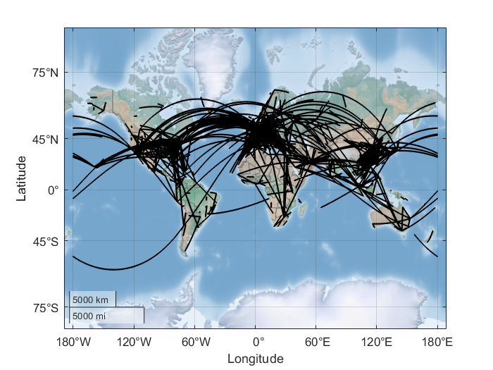

Figure 5.2.1-2 illustrates the modelled scenario between EESS (passive) and the AM(R)S for the randomly drawn routes illustrated in Figure 5.2.1-3. The MAI was placed as such to represent a combination of over-land and over-water scenarios.

FIGURE 5.2.1-2

EESS (passive) MAI and randomly drawn air routes

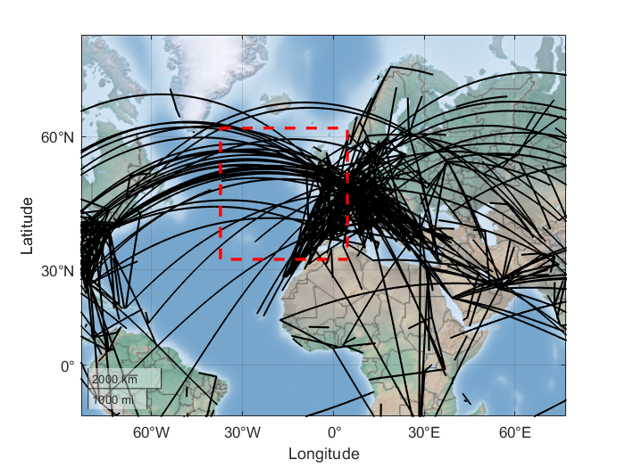

The aggregate RFI experienced by the EESS (passive) satellite due to WAIC transmissions in the 4 200 – 4 400 MHz band is assessed by simulating the dynamic nature of the satellite and a wide-range of pointing angles of the sensor antenna for each satellite position. The simulation only retains the data points when the EESS (passive) sensor antenna boresight points within the MAI. To model the conical sensors, the useful scan range along the satellite subtrack is considered. The useful scan range is determined by the useful swath width that characterizes the sensor antenna, as described in Section 2.2 of Recommendation ITU-R RS.1861 (see Figure 2 of the Recommendation). At each time step in the simulation (i.e., at each satellite position), many potential pointing angles are considered (i.e., granular angular resolution), while accounting for the sensor’s offset angle from the nadir direction (i.e., conical scan around the nadir direction).

Likewise, for every position of the satellite, the WAIC transmitter gain relative to the EESS (passive) satellite is calculated. It is assumed that all WAIC transmitters on board an aircraft does not exceed an equivalent isotropic radiated power of -20 dBm within the EESS (passive) reference bandwidth (200 MHz) and referenced to a point source, which is assumed to be located at the geometrical center of the aircraft. Therefore, it is assumed that the gain of the WAIC transmitter is equal in all directions.

At the nth time step of the simulation, ith pointing angle of the EESS (passive) sensor, and from the kth active WAIC transmitter (i.e., per aircraft), the received interference is calculated as follows:

where:

: Interference power received in the EESS (passive) reference bandwidth (dBW/200 MHz)

: EIRP density of the WAIC transmitter in the EESS (passive) reference bandwidth (dBW/200 MHz)

: Gain of the EESS (passive) sensor antenna in the direction of the WAIC transmitter (dBi)

: Free space path loss (dB)

The aggregate interference from all WAIC transmitters at each time step (i.e., each EESS (passive) satellite position) and for each potential EESS (passive) sensor antenna pointing angle is computed in the linear domain. The data on interfering power levels is used to generate statistical distributions of observed interference levels while the EESS (passive) sensor is performing SST measurements.

#### 5.2.1.4 Sharing study results

The figures below display the study results for sharing between EESS (passive) (sensors B4 & B5) and WAIC systems. The colored markers represent instances where the RFI is greater than or equal to -189 dBW/MHz for 0.1% of time.

FIGURE 5.2.1-3

Aggregate RFI - Sensor B4 (0.1% CCDF)

FIGURE 5.2.1-4

Aggregate RFI - Sensor B5 (0.1% CCDF)

### 5.2.2 Summary and conclusion

TBD

## 5.3 EESS (passive) and Aeronautical Radionavigation service systems in the 4 200-4 400 MHz band

### 5.3.1 Study A: USA

#### 5.3.1.2 Radio Altimeter (RA) characteristics

Technical and operational characteristics and deployment related parameters of radio altimeters utilizing the band 4 200 – 4 400 MHz, are contained in Recommendation ITU-R M.2059, and Table 5.3.1-1 displays the radio altimeter’s technical and deployment related characteristics applied in the study. Additionally, Figure 5.3.1-1 displays the antenna pattern assumed in the study, which aligns with the characteristics described in Recommendation ITU-R M.2059.

TABLE 5.3.1-1

Assumed RA technical and deployment related characteristics

|  |  |
| --- | --- |
| Parameter | Value |
| Transmitted power (W) | 0.6 |
| Transmission signal bandwidth (MHz) | 180 |
| Antenna gain (dBi) (peak) | 10 |
| Antenna half-power beamwidth (degrees) | 40 – 60 |
| Polarization | H |
| Aircraft altitude (km) | 12 |

FIGURE 5.3.1-1

RA antenna pattern used in the study



#### 5.3.1.3 Propagation Modeling

The impact of RA sea surface reflections in the direction of EESS (passive) is observed in this study. Recommendation ITU-R P.2146 provides a method for predicting the bistatic scattering coefficient for the sea surface. The model can be applied at any elevation angle, except grazing incidence, and is applicable for frequencies up to 100 GHz, and for wind speeds between 0.5 m/s to 25 m/s. Additionally, the bistatic scattering coefficient has two components 1) The diffuse component, which is the fraction of incident power from an incident direction scattered to any arbitrary receive direction, and 2) a coherent componentx, which is the fraction of the incident power scattered back to the incident direction. The study considers sea surface reflections in the direction of the EESS (passive) satellite, which is best represented by the diffuse component. Table 5.3.1-2 displays the assumed parameters when computing the bistatic scattering coefficient:

TABLE 5.3.1-2

Assumed RA technical and deployment related characteristics

|  |  |  |
| --- | --- | --- |
| Parameter | Value | Discussion |
| Frequency (GHz) | 4.3 | - |
| Sea surface salinity (ppt2) | 35 | Recommendation ITU-R P.2146 default value |
| Sea surface temperature (C) | 0, 15, 30 | Recommendation ITU-R P.2146 default values. Uniformly sampled value in the Monte Carlo Analysis |
| Wind speed (m/s) | 0.5 – 25 | Uniformly sampled value in the Monte Carlo Analysis |
| Inverse wave age | 0.85 | Recommendation ITU-R P.2146 default value |
| Cut off wavenumber ratio | 0.5 | Recommendation ITU-R P.2146 default value |
| Incidence Azimuth/Elevation Angle (deg) | Variable | Dynamically determined based on the RA footprint projection on the ground. |
| Scattered Azimuth/Elevation Angle (deg) | Variable | Dynamically determined based on the direction of the RA footprint projection on ground relative to the EESS (passive) satellite. |

#### 5.3.1.5 Methodology: Impact of RA sea surface reflections in the direction of EESS (passive)

[*Editor’s Notes: Consideration will be given to analysing cold calibration scenarios]*

The impacts of reflected power off sea surface from RAs are analysed using the method for predicting the diffuse bistatic scattering coefficient, as described in Recommendation ITU-R P.2146. To assess the impacts of reflected power from sea surface, it is necessary to project the RA footprint onto the sea surface. A series of examples are shown below. The RA footprint is represented by a pixelated surface constrained by a beam width of 140°. For example, Figure 5.3.1-2 displays an example antenna footprint of a RA at an altitude of 12 000 m, using a resolution of 0.002°, based on the antenna pattern from Figure 5.3.1-1.

FIGURE 5.3.1-2

Projection of the RA antenna pattern on the ground



Therefore, the incident power flux density (PFD) produced by the RA is as shown in Figure 5.3.1-3.

FIGURE 5.3.1-3

Incident PFD produced by the RA

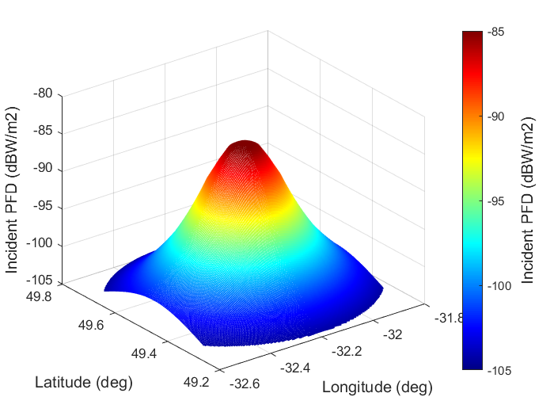

To determine the bistatic scattering coefficient, the simulation calculates the RA’s incidence zenith angle, , and the incident azimuth, , with respect to the direction of the wind. Additionally, the simulation also calculates the scattering zenith angle, , and the scattering azimuth, , in the direction of the satellite. The geometric configuration of bistatic scattering from sea surface, accounting for the wind’s direction, can be observed in Figure 1 of Recommendation ITU-R P.2146. Per the Recommendation, the sea surface is treated as a two-scale roughness having large-scale roughness and small-scale roughness, where they are associated with long gravity waves and short capillary waves (wind), respectively. Therefore, the diffuse component of the bistatic scattering coefficient is the sum of the two components. An example is presented in Figure 5.3.1-4, which shows the bistatic scattering coefficient in the direction of a satellite located at an elevation angle of approximately 50° and at an azimuth of approximately 30°.

FIGURE 5.3.1-4

Bistatic scattering coefficient in an arbitrary satellite direction

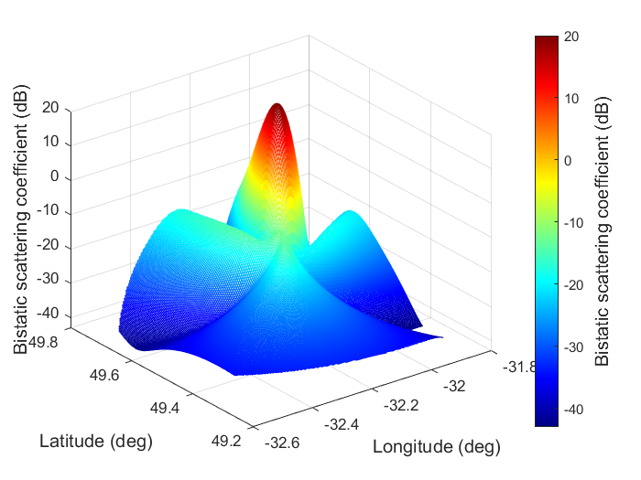

The reflected PFD can be then considered in the satellite’s direction, as displayed in Figure 5.3.1-5. Furthermore, the total reflected power towards the EESS satellite can be computed as described in Attachment E, equation e.5, of Recommendation ITU-R P.2146, which is also based on the bistatic radar equation. It is assumed that the footprint of the RA is seen as a single point by the EESS (passive) satellite. The sum of the power of each pixel is taken in the linear domain to evaluate the total reflected power by the sea surface.

FIGURE 5.3.1-5

Reflected PFD in the direction of an arbitrary satellite position

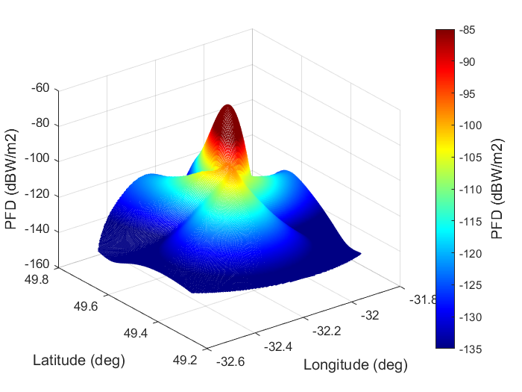

The simulation methodology to analyse sea surface reflections focuses on examining the impact of these reflections in the North Atlantic region as observed by the EESS (passive) satellite. An aggregate effect is observed by simulating randomly distributed aircrafts within the region of interest using commonly used air routes. The simulation only retains the data points when the EESS (passive) sensor antenna boresight points within the measurement area of interest. At each time step in the simulation (i.e., at each satellite position), a wide range of potential pointing angles are considered, while accounting for the sensor’s offset angle from the nadir direction (i.e., conical scan around the nadir direction within the useful scan range). The aggregate RFI from the radio altimeter sea surface reflections is computed for each potential EESS (passive) sensor pointing angle. Figure 5.3.1-6 illustrates an example scenario, representing EESS (passive) satellite locations, the EESS (passive) measurement area of interest, and all potential flight routes.

FIGURE 5.3.1-6

Example scenario with all potential flight routes

#### 5.3.1.6 Sharing study results

### 5.3.2 Summary and conclusion

# 6 Compatibility studies between EESS (passive) in the 4 200-4 400 MHz band and services adjacent to this band

## 6.1 EESS (passive) in the 4 200-4 400 MHz band and Fixed-satellite (Earth-to-space) service systems in the adjacent band 3 600-4 200 MHz

Under this section the feasibility of coexistence between EESS passive in 4 200-4 400 MHz and FSS in 3 600-4 200 MHz is assessed.

[TBD]

### 6.1.1 Fixed-satellite service system characteristics

### 6.1.2 Methodology and results

### 6.1.3 Summary and conclusion

## 6.2 EESS (passive) in the 4 200-4 400 MHz band and Mobile (except aeronautical mobile) service systems in the adjacent band 3 700-4 200 MHz

### 6.2.1 Mobile (except aeronautical mobile) service system characteristics

### 6.2.2 Methodology and results

### 6.2.3 Summary and conclusion

## 6.3 EESS (passive) in the 4 200-4 400 MHz band and Fixed service systems in the adjacent band 4 400-4 500 MHz

### 6.3.1 Fixed service system characteristics

### 6.3.2 Methodology and results

### 6.3.3 Summary and conclusion

## 6.4 EESS (passive) in the 4 200-4 400 MHz band and Terrestrial IMT systems[1] in the adjacent band 4 400-4 800 MHz

### 6.4.1 Terrestrial IMT system characteristics

### 6.4.2 Methodology and results

### 6.4.3 Summary and conclusion

## 6.5 EESS (passive) in the 4 200-4 400 MHz band and Aeronautical Mobile service in the adjacent band 4 400-4 800 MHz

### 6.5.1 Aeronautical mobile system characteristics

### 6.5.2 Methodology and results

### 6.5.3 Summary and conclusion

## 6.6 EESS (passive) in the 4 200-4 400 MHz band and Maritime Mobile service in the adjacent band 4 400-4 800 MHz

### 6.6.1 Maritime mobile system characteristics

### 6.6.2 Methodology and results

### 6.6.3 Summary and conclusion

## 6.7 EESS (passive) in the 4 200-4 400 MHz band and Land Mobile service in the adjacent band 4 400-4 800 MHz

### 6.7.1 Land mobile system characteristics

### 6.7.2 Methodology and results

### 6.7.3 Summary and conclusion

# 7 Sharing studies between EESS (passive) and incumbent services in the 8 400-8 500 MHz band

## 7.1 ITU-R Recommendations and Reports

The ITU-R Recommendations and Reports listed in Section 4.1 apply to conducting sharing and compatibility studies between EESS (passive) and incumbent services in the 8 400-8 500 MHz band.

### 7.1.1 Technical and Operational Characteristics of EESS (passive) in the band 8 400-8 500 MHz

To perform sharing and compatibility studies between EESS (passive) and incumbent services in the 8 400 – 8500 MHz band, and to determine the potential RFI into EESS (passive), the characteristics of the sensors described in the band 6 425 – 7 250 MHz are used, as displayed in Table 7-1. These characteristics, including the sensor types employing conical scanning mechanisms and their beam dynamics, are expected to be the same in the 8 400 – 8 500 MHz band. Additionally, the sensor antenna pattern is expected to reflect the antenna pattern described in Recommendation ITU-R RS.1813. It should be noted that the sensitivity of the sensors is based on permissible interference levels and reference bandwidths for the frequency bands preferred for SST measurements, as described in Section 7.1.2.

TABLE 7-1

EESS (passive) sensor characteristics in the 6 425-7 250 MHz frequency band

|  |  |  |  |  |  |
| --- | --- | --- | --- | --- | --- |
|  | Sensor B3 | Sensor B4 | Sensor B5 | Sensor B6 | Sensor B7 |
| Sensor type | Conical scan | Conical scan | Conical scan | Conical scan | Conical scan |
| **Orbit parameters** | | | | | |
| Altitude (km) | 830 | 699.6 | 820 | 970 | 665.96 |
| Inclination (degree) | 98.85 | 98.186 | 98.702 | 99.3 | 98.06 |
| Eccentricity | 0 | 0.002 | 0.0011441 | 0.00117 | 0.0015 |
| Repeat period (days) |  | 16 | 29 | 14 | 3 |
| **Sensor antenna parameters** | | | | | |
| Number of beams | 1 | 1 | 4 | 1 | 1 |
| Antenna size (m) | 1.0 | 2.0 | 7.4 | 1.0 | 2.0 |
| Maximum beam gain | 35.5 dBi | 40.6 dBi | 51.5 dBi | 36 dBi | 40.6 dB |
| Polarization | V, H | V, H | V, H | V, H | V, H |
| −3 dB beamwidth (degree) | 2.5 | 1.8 | 0.43-0.58 | 3.11 | 1.8 |
| Instantaneous field of view (km) | 70 × 167 | 35 × 62 | 19 × 11 | 74 × 122 | 33 × 57 |
| Off-nadir pointing angle | 53.3° | 47.5° | 46.5° | 44° | 47.7° |
| Incidence angle at Earth | 65° | 55° | 55° | 53° | 55° |
| Swath width (km) | 2 200 | 1 450 | >1 900 | 1 700 | 1 535 |
| Antenna efficiency |  | 0.57 |  | 0.6 | 0.57 |
| Beam dynamics | 2.5 s/scan period, counter clockwise | 40 rpm | 7.8 rpm | 3.57 s/scan | 40 rpm |
| Sensor antenna pattern | See Recommendation ITU‑R RS.1813 | See Recommendation ITU‑R RS.1813 |  | See Recommendation ITU‑R RS.1813 | See Recommendation ITU‑R RS.1813 |
| Cold calibration antenna gain | 22.3 dBi | 25.6 dBi | 51.5 dBi | 25 dB | 25.6 dBi |
| Cold calibration angle (degrees re. satellite track) | 315º | 115.5º | 0 º | 158° | 118.7º |
| Cold calibration angle (degrees re. nadir direction) | 90º | 97.0º | 45º-180º | 80 ° | 94.6º |

### 7.1.2 Interference criteria of EESS (passive) in the band 8 400 – 8 500 MHz

The interference criteria for EESS (passive) is defined by Recommendation ITU-R RS.2017. Although the frequency band 8 400 – 8 500 MHz is not defined in the Recommendation, the reference bandwidth, maximum interference level, and the permissible percentage of area/time that the interference level may be exceeded is defined for the 4 200 – 4 400 MHz and 6 425 – 7 250 MHz bands. In both scenarios, the interference thresholds are the same, as shown in Table 7-2. The equivalent interference criteria for EESS (passive) in the 8 400 – 8 500 MHz band can be computed based on these thresholds. Therefore, when assuming a reference bandwidth of 100 MHz, the equivalent interference criteria is -169 dBW / 100 MHz (-189 dBW / MHz) and it should not be exceeded for more than 0.1% of time or area within a measurement area of 10 000 000 km2.

TABLE 7-2

Interference criteria for satellite passive remote sensing in the bands 4.2 – 4.4 GHz and 6.425 – 7.25 GHz

| Frequency band(s)  (GHz) | Reference bandwidth (MHz) | Maximum interference level  (dBW) | Percentage of area or time permissible interference level may be exceeded(1) (%) | Scan mode  (N, C)(2) |
| --- | --- | --- | --- | --- |
| 4.2-4.4 | 200 | −166 | 0.1 | N, C |
| 6.425-7.25 | 200 | −166 | 0.1 | N, C |
| (1) For a 0.1% level, the measurement area is a square on the Earth of 10 000 000 km2 unless otherwise justified.  (2) N: Nadir, Nadir scan modes concentrate on sounding or viewing the Earth’s surface at angles of nearly perpendicular incidence. The scan terminates at the surface or at various levels in the atmosphere according to the weighting functions. C: Conical, Conical scan modes view the Earth’s surface by rotating the antenna at an offset angle from the nadir direction. | | | | |

## 7.2 EESS (passive) and Mobile service (except aeronautical mobile) systems in the 8 400-8 500 MHz band

### 7.2.1 Mobile service system characteristics

### 7.2.2 Methodology and results

### 7.2.3 Summary and conclusion

## 7.3 EESS (passive) and Fixed service systems in the 8 400-8 500 MHz band

### 7.3.1 Study A: USA

#### 7.3.1.1 Fixed service system characteristics

Technical and operational characteristics and deployment related parameters of fixed service systems, as provided by WP 5C, are contained in Recommendation ITU-R F.758 and Recommendation ITU-R F.2086. Additionally, the antenna radiation patterns for all fixed service systems are represented by Recommendation ITU-R F.1245, as the pattern provides an average of the antenna sidelobe values and that the sharing scenario considers aggregate interference assessments to EESS (passive). Tables 7.3.1-1 and 7.3.1-2 present the point-to-point fixed service characteristics from ITU-R Recommendations F.758 and F.2086, as well as the assumptions applied in the study, respectively.

TABLE 7.3.1-1

Parameters from Recommendation ITU-R F.758 used in the sharing study

|  |  |  |
| --- | --- | --- |
| Parameter | Value | Discussion |
| Channel spacing and receiver noise bandwidth (MHz) | 1.25, 2.5, 5, 7, 10, 11.662, 14, 20, 28, 29.65, 30, 40, 60, 80 | - |
| Tx output power range (dBW) | −6.5… 13 | - |
| Tx output power density range (dBW/MHz)(1) | −25.5…3 | The Tx output power density value is uniformly randomized. |
| Feeder/multiplexer loss range (dB) | 0…3.0 | Feeder loss value is uniformly randomized |
| Antenna gain range (dBi) | 12…48.6 | Antenna gain value is uniformly randomized. |
| e.i.r.p. range (dBW) | 5.5…55 | - |
| e.i.r.p. density range (dBW/MHz)(1) | −13.5…45 | The randomized values of the TX output power density and antenna gain is always within this EIRP range. |
| 1. To calculate the values for the Tx/e.i.r.p. densities, channel spacing/bandwidth needs to be identified. In these tables, the channel spacing indicated in the **bold text** is used. Where a modal value (Mode) is provided, it is to be taken as indicative within the range specified and further sensitivity analysis may be required on a case-by-case basis to assess a given interference potential due to the variations within the range specified. | | |

TABLE 7.3.1-2

Parameters from Recommendation ITU-R F.2086 used in the sharing study

|  |  |  |
| --- | --- | --- |
| Parameter | Value | Discussion |
| Antenna Azimuth (degrees) | 0 – 360 | Antenna azimuth values are randomized in a uniform distribution. |
| Antenna Elevation Angle (degrees) | Median: 0.13  Standard Deviation: 3.24 | A normal distribution was created for each of these parameters. Parameters were extracted from the representative deployment in France between 8.025 – 8.5 GHz. |
| Antenna height (m) | Median: 21  Standard Deviation: 25 |

#### 7.3.1.2 Propagation Modeling

Recommendation ITU-R P.619 is applicable for sharing between stations in space and stations on the Earth’s surface. Section 3.2 of the Recommendation describes the mechanisms to compute the clear-air basic transmission loss for each unwanted transmitter in a multiple-entry Earth-space interference calculation. To compute the basic transmission loss, the study considers the free space basic transmission loss. Additionally, it should be noted that WP 3M is currently working on updating Recommendation ITU-R P.2108-1 (Section 3.3, statistical Earth-to-space clutter loss model).

#### 7.3.1.3 Methodology

[*Editor’s Notes: Consideration will be given to analysing cold calibration scenarios]*

To conduct the sharing study, FS system characteristics are randomized within a Monte Carlo analysis. Recommendation ITU-R F.2086 notes that although there may be dependency between some of the parameters in Table 7.3.1-2, a sharing scenario could consider a “number of randomly placed stations without establishing a link relationship,” in which the link length statistics would not be applied and the antenna height and elevation angle distributions are instead applied for each FS station.

Methodologies to model the density of point-to-point (PP) FS systems are not defined in the existing ITU-R Recommendations that provide FS system parameters and deployment scenarios. To model the density of FS emitters and sites, FS site locations for different administrations were obtained from the eMIFR (on-line query for terrestrial services). However, there currently is not an extensive database of FS sites for all administrations within the eMIFR between 8.4 – 8.5 GHz. In cases where there is not a representative set of FS sites between 8.4 – 8.5 GHz, the frequency search range was expanded to identify the greatest number of FS emitters within any 100 MHz between 7.11 – 8.5 GHz for each administration[2]. FS deployments in the following administrations are considered: Belgium, Germany, Denmark, Spain, France, United Kingdom, Netherlands, Italy, Ireland, Luxembourg, Norway, Portugal, and Switzerland (resulting in approximately 2 000 FS emitters).

Figure 7.3.1-1 illustrates an example scenario between EESS (passive) and the FS. The figure displays the EESS (passive) measurement area of interest (MAI), as defined by Recommendation ITU-R RS.2017 (area on the Earth equal to 10 000 000 km2), and distributed FS sites (orange markers) for the analysed countries. The MAI was placed as such to represent a combination of over-land and over-water scenarios.

FIGURE 7.3.1-1

EESS (passive) and FS sharing scenario (orange markers are the FS sites)

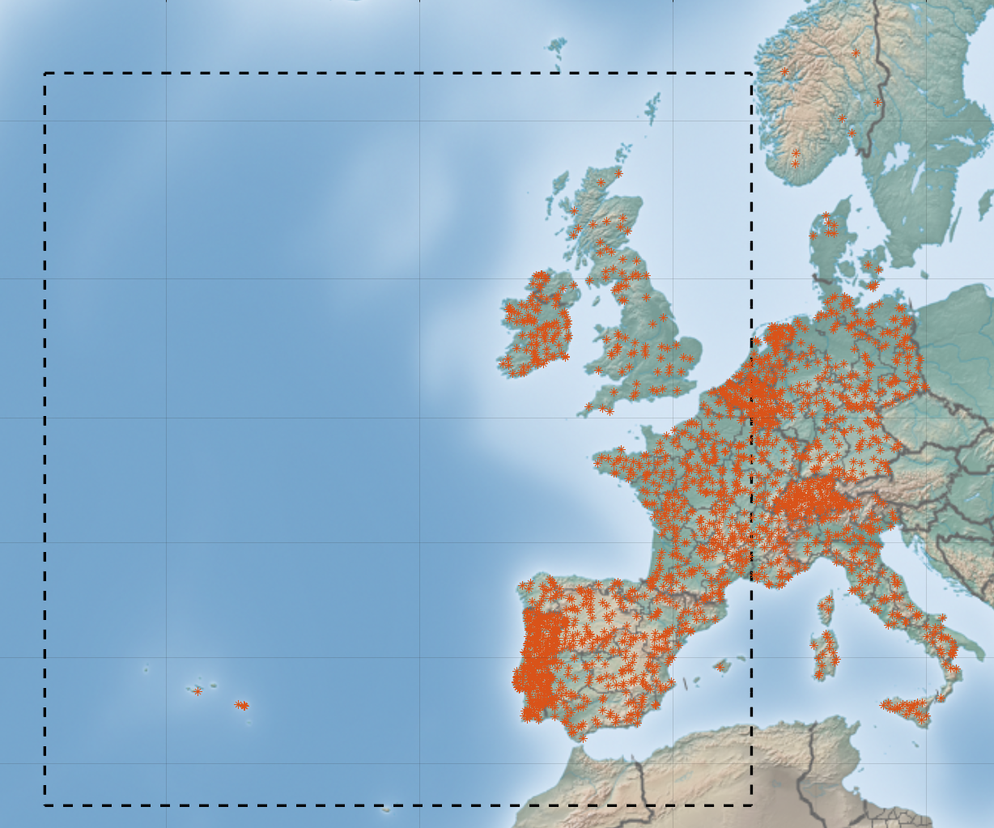

The aggregate RFI experienced by the EESS (passive) satellite due to FS deployments operating in the 8 400 – 8 500 MHz band is assessed through dynamic simulations. The analysis is conducted by simulating the dynamic nature of the satellite and a wide range of potential pointing angles (i.e., small angular resolution) of the sensor for each satellite position. To have many measured samples within the MAI, the satellite orbit is simulated over a 7-day period with a granular resolution per Monte Carlo trial. Furthermore, the simulation only retains the data points when the EESS (passive) sensor antenna boresight points within the MAI. To model the conical sensors, the useful scan range along the satellite subtrack is considered. The useful scan range is determined by the useful swath width that characterizes the sensor antenna, as described in Section 2.2 of Recommendation ITU-R RS.1861 (see Figure 2 of the Recommendation). At each time step in the simulation (i.e., at each satellite position), many potential pointing angles are considered, while accounting for the sensor’s offset angle from the nadir direction (i.e., conical scan around the nadir direction).

Likewise, for every position of the satellite, the FS transmitter gain relative to the EESS passive satellite is calculated. The antenna model of the FS systems is based on Recommendation ITU-R F.1245 and are generated for each FS system depending on their randomized antenna characteristics. The randomization of each FS transmitter’s characteristics (e.g., pointing angles, transmit gain) occurs once per Monte Carlo trial.

At the nth time step of the simulation, ith pointing angle of the EESS (passive) sensor, and from the kth FS emitter, the received interference is calculated as follows:

where:

: Interference power received in the EESS (passive) reference bandwidth (dBW/MHz)

: Output power density of the FS transmitter in the FS reference bandwidth (dBW/MHz)

: Gain of the FS transmit antenna in the direction of the EESS (passive) satellite (dBi)

: Gain of the EESS (passive) sensor antenna in the direction of the FS transmitter (dBi)

: Free space path loss (dB)

The aggregate interference from all FS transmitters at each time step and potential sensor antenna pointing angle is computed as the sum of all potential RFI sources in the linear domain. The data on interfering power levels is used to generate statistical distributions of observed interference levels while the EESS (passive) sensor is performing SST measurements.

7.3.2.1 Sharing study resultsThe study results for two scenarios using Sensors B4 and B5 are shown below. The colored markers represent instances where the RFI is greater than or equal to -189 dBW/MHz for 0.1% of time.

FIGURE 7.3.1-2

Aggregate RFI - Sensor B4 (0.1% CCDF)

FIGURE 7.3.1-3

Aggregate RFI - Sensor B5 (0.1% CCDF)

### 7.3.3 Summary and conclusion

## 7.4 EESS (passive) and Space Research (deep space) (space-to-Earth) service systems in the 8 400-8 500 MHz band

### 7.4.1 Space Research (deep space) service system characteristics

### 7.4.2 Methodology and results

### 7.4.3 Summary and conclusion

# 8 Compatibility studies between EESS (passive) in the 8 400-8 500 MHz band and services adjacent to this band

## 8.1 EESS (passive) in the 8 400-8 500 MHz band and Earth exploration-satellite (space-to-Earth) service systems in the adjacent band 8 215-8 400 MHz

### 8.1.1 Earth exploration-satellite service system characteristics

### 8.1.2 Methodology and results

### 8.1.3 Summary and conclusion

## 8.2 EESS (passive) in the 8 400-8 500 MHz band and Fixed-satellite (Earth-to-space) service systems in the adjacent band 8 215-8 400 MHz

### 8.2.1 Fixed-satellite service system characteristics

### 8.2.2 Methodology and results

### 8.2.3 Summary and conclusion

## 8.3 EESS (passive) in the 8 400-8 500 MHz band and terrestrial component of IMT[3] in the adjacent band 8 215-8 400 MHz

### 8.3.1 Terrestrial IMT service system characteristics

### 8.3.2 Methodology and results

### 8.3.3 Summary and conclusion

## 8.4 EESS (passive) in the 8 400-8 500 MHz band and fixed service systems in the adjacent band 8 215-8400 MHz

### 8.4.1 Fixed service system characteristics

### 8.4.2 Methodology and results

### 8.4.3 Summary and conclusion

## 8.5 EESS (passive) in the 8 400-8 500 MHz band and Radiolocation service systems in the adjacent band 8 500-8 550 MHz

### 8.5.1 Radiolocation service system characteristics

### 8.5.2 Methodology and results

### 8.5.3 Summary and conclusion

# 9 Summary of the sharing and compatibility studies between EESS (passive) and services within and adjacent to the 4 200-4 400 MHz and 8 400-8 500 MHz bands.

1. Taking into account WRC-27 agenda item 1.7.
2. The emission characteristics of PP FS systems are consistent between 7.11 – 7.9 GHz and 7.725 – 8.5 GHz in Recommendation ITU-R F.758-7.
3. Taking into account WRC-27 agenda item 1.7.